Hands on 1
Spring Data JPA - Quick Example

Step 1: Generate Spring Boot Project
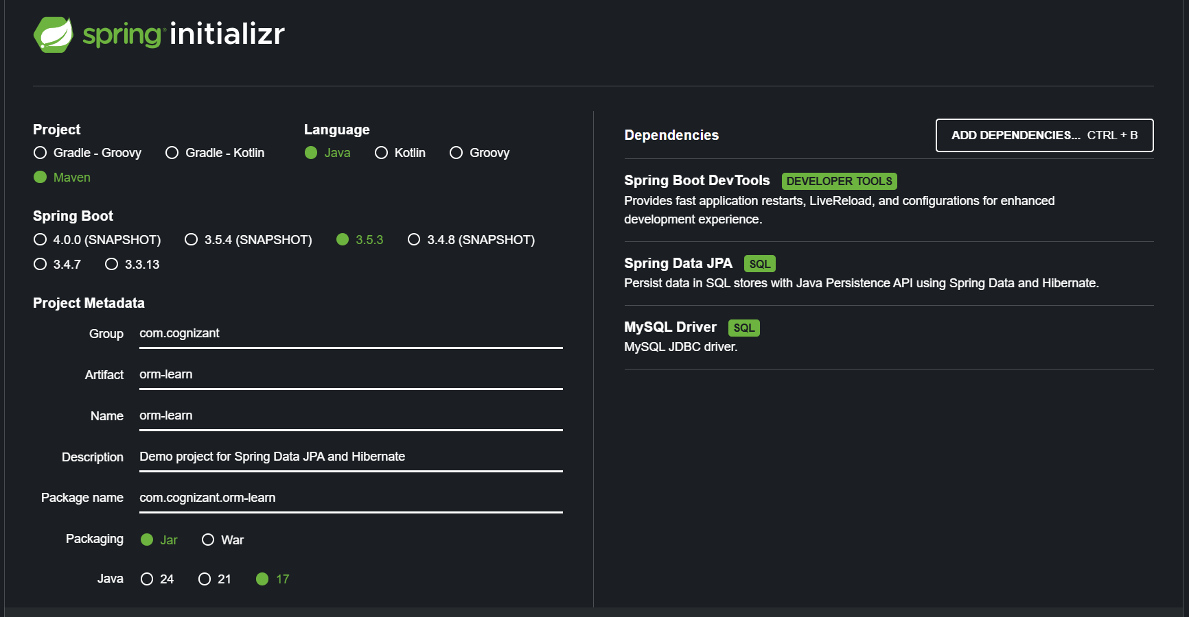

Step 2: Import the jar file in Eclipse
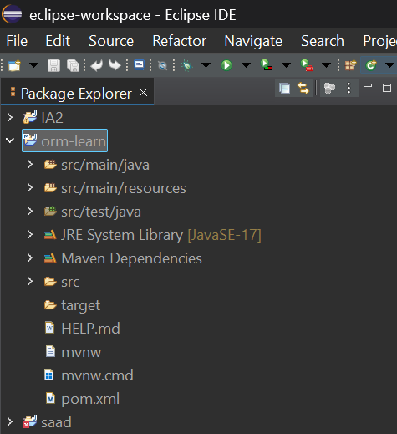

Step 3: Open Workbench and create schema, tables and add values
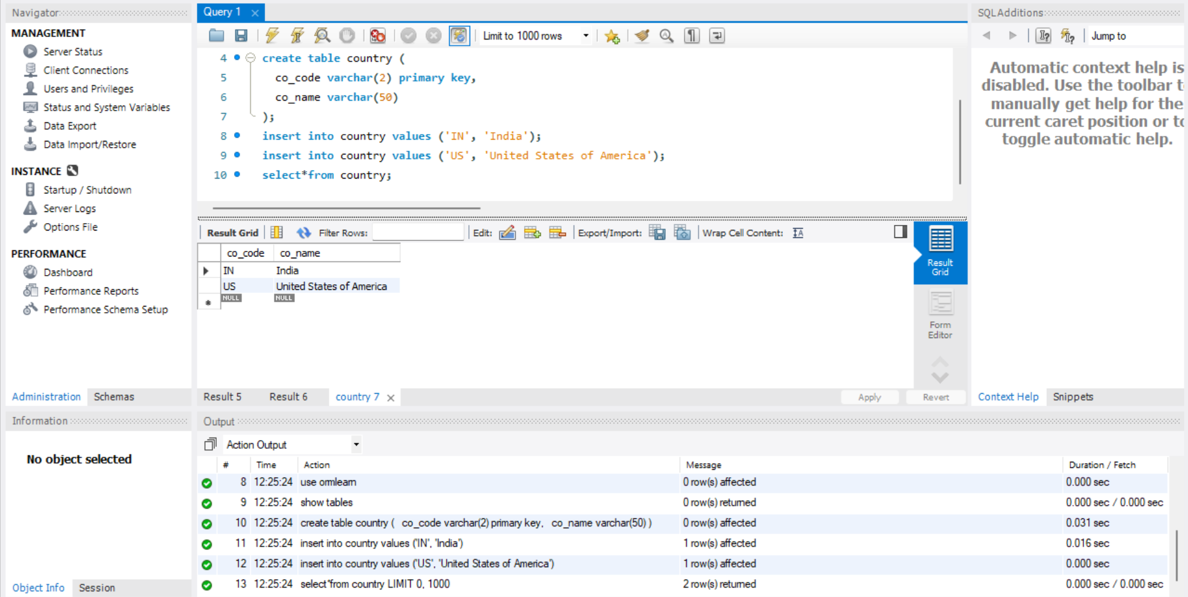

Step 4: src/main/resources/application.properties
spring.application.name=orm-learn
# Logs
logging.level.org.springframework=info
logging.level.com.cognizant=debug
logging.level.org.hibernate.SQL=trace
logging.level.org.hibernate.type.descriptor.sql=trace
logging.pattern.console=%d{dd-MM-yy} %d{HH:mm:ss.SSS} %-20.20thread %5p %-25.25logger{25} %25M %4L %m%n

# Database
spring.datasource.driver-class-name=com.mysql.cj.jdbc.Driver
spring.datasource.url=jdbc:mysql://localhost:3306/ormlearn
spring.datasource.username=root
spring.datasource.password=saadma11

# Hibernate
spring.jpa.hibernate.ddl-auto=validate
spring.jpa.properties.hibernate.dialect=org.hibernate.dialect.MySQLDialect
Country.java
package com.cognizant.orm_learn.model;
import jakarta.persistence.*;

@Entity
@Table(name = "country")
public class Country {

@Id
@Column(name = "co_code")
private String code;

@Column(name = "co_name")
private String name;

public String getCode() { return code; }
public void setCode(String code) { this.code = code; }

public String getName() { return name; }
public void setName(String name) { this.name = name; }

@Override
public String toString() {
return "Country [code=" + code + ", name=" + name + "]";
}
}

POM file:
<?xml version="1.0" encoding="UTF-8"?>
<project xmlns="http://maven.apache.org/POM/4.0.0" xmlns:xsi="http://www.w3.org/2001/XMLSchema-instance"
xsi:schemaLocation="http://maven.apache.org/POM/4.0.0 https://maven.apache.org/xsd/maven-4.0.0.xsd">
<modelVersion>4.0.0</modelVersion>
<parent>
<groupId>org.springframework.boot</groupId>
<artifactId>spring-boot-starter-parent</artifactId>
<version>3.5.3</version>
<relativePath/> <!-- lookup parent from repository -->
</parent>
<groupId>com.cognizant</groupId>
<artifactId>orm-learn</artifactId>
<version>0.0.1-SNAPSHOT</version>
<name>orm-learn</name>
<description>Demo project for Spring Data JPA and Hibernate</description>
<url/>
<licenses>
<license/>
</licenses>
<developers>
<developer/>
</developers>
<scm>
<connection/>
<developerConnection/>
<tag/>
<url/>
</scm>
<properties>
<java.version>17</java.version>
</properties>
<dependencies>
<dependency>
<groupId>org.springframework.boot</groupId>
<artifactId>spring-boot-starter-data-jpa</artifactId>
</dependency>

<dependency>
<groupId>org.springframework.boot</groupId>
<artifactId>spring-boot-devtools</artifactId>
<scope>runtime</scope>
<optional>true</optional>
</dependency>
<dependency>
<groupId>com.mysql</groupId>
<artifactId>mysql-connector-j</artifactId>
<scope>runtime</scope>
</dependency>
<dependency>
<groupId>org.springframework.boot</groupId>
<artifactId>spring-boot-starter-test</artifactId>
<scope>test</scope>
</dependency>
<dependency>
<groupId>jakarta.persistence</groupId>
<artifactId>jakarta.persistence-api</artifactId>
<version>3.1.0</version> <!-- or similar -->
</dependency>
</dependencies>
<build>
<plugins>
<plugin>
<groupId>org.springframework.boot</groupId>
<artifactId>spring-boot-maven-plugin</artifactId>
</plugin>
</plugins>
</build>
</project>

CountryRepository.java

package com.cognizant.orm_learn.repository;
import org.springframework.data.jpa.repository.JpaRepository;
import org.springframework.stereotype.Repository;

import com.cognizant.orm_learn.model.Country;

@Repository
public interface CountryRepository extends JpaRepository<Country, String> {
}
CountryService.java
package com.cognizant.orm_learn.service;

import java.util.List;

import org.springframework.beans.factory.annotation.Autowired;
import org.springframework.stereotype.Service;
import org.springframework.transaction.annotation.Transactional;

import com.cognizant.orm_learn.model.Country;
import com.cognizant.orm_learn.repository.CountryRepository;

@Service
public class CountryService {

@Autowired
private CountryRepository countryRepository;

@Transactional
public List<Country> getAllCountries() {
return countryRepository.findAll();
}
}
OrmLearnApplication.java
package com.cognizant.orm_learn;
import java.util.List;
import org.slf4j.Logger;
import org.slf4j.LoggerFactory;
import org.springframework.boot.SpringApplication;
import org.springframework.boot.autoconfigure.SpringBootApplication;
import org.springframework.context.ApplicationContext;

import com.cognizant.orm_learn.model.Country;
import com.cognizant.orm_learn.service.CountryService;

@SpringBootApplication
public class OrmLearnApplication {

private static final Logger LOGGER = LoggerFactory.getLogger(OrmLearnApplication.class);
private static CountryService countryService;

public static void main(String[] args) {
ApplicationContext context = SpringApplication.run(OrmLearnApplication.class, args);
countryService = context.getBean(CountryService.class);
testGetAllCountries();
}

private static void testGetAllCountries() {
LOGGER.info("Start");
List<Country> countries = countryService.getAllCountries();
LOGGER.debug("countries={}", countries);
LOGGER.info("End");
}
}

Output:
The countries from the database are displayed successfully
